**Mechanics:**

Player:

* Crouch/Sneak
* Throw Items to distract enemies
* Pick up throwing items from stockpiles
* Take Damage when in cold for certain amount of time
* Decrease cold amount when near fire
* Instant death from gang (shot)

Enemy:

* Patrol
* shoot if sees player
* Goes towards noises within hearing distance then return to patrol after a while

Person To Rescue:

* Follow Player
* Attempt to avoid enemies?

Environment

* Random Spawning of Items?

**Visual Effects:**

Environment:

* Snow Falling
* Footsteps in Snow
  + Appearing and Disappearing
* Flickering Lights
* Fog
* Trash Fire

People:

* Breath

Other:

* Breaking of weapons

**Key Events**

* Start Game
  + Get a phone call or message that your friend has been captured
* Alleyway Maze
  + Enemy patrolling
* Gang Hideout
  + Apartment Building with gang members around (no one paying too much attention - only close proximity and noise will cause the enemies to notice the player)
  + Friend upstairs tied up
* End
  + Rescue friend and both successfully make it out of the hideout back home

**Objectives/Challenges/Rewards**

* Objective: Rescue your friend
* Challenges: Being aware of enemies around you as well as staying warm
  + Figure out how to get past the enemies without the use of force
* Reward: The feeling of accomplishment of beating the game

**Type of Progression**

* Non-Linear
  + Find your way to the gang hideout through small alleyways, while finding ways around the enemies

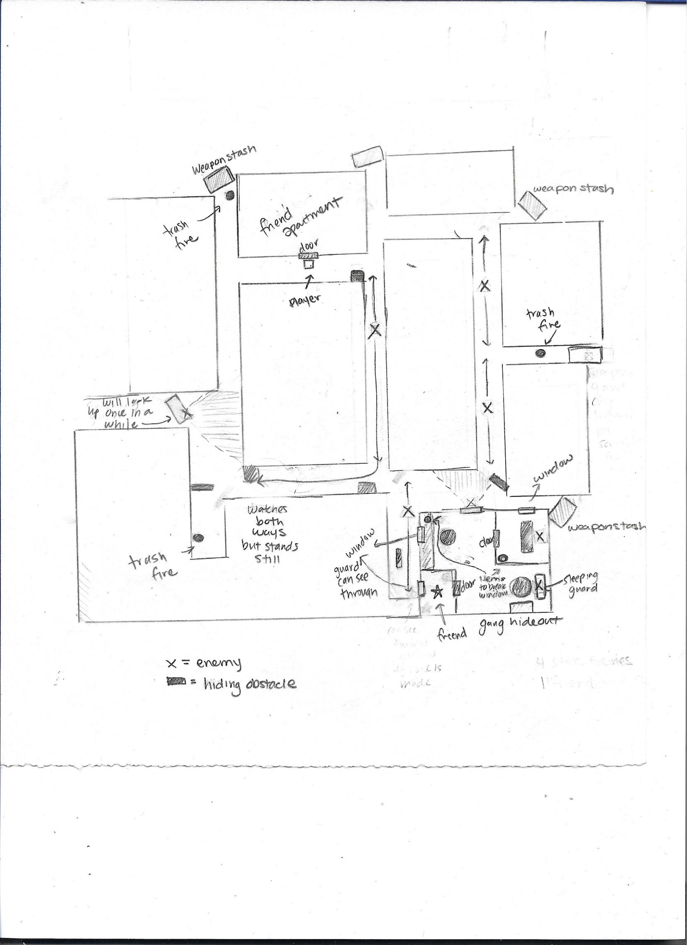Map Version 1